UML-1 – Class Diagram for a Customer Order in a Retail System
Class Diagrams
A Class Diagram gives an overview of a system by showing its classes and the relationships among them. Class diagrams are static -- they display what interacts but not what happens when they do interact.
The class diagram below models a customer order from a retail catalog. The central class is the Order. Associated with it is the Customer making the purchase and the Payment. A Payment is one of three kinds: Cash, Check, or Credit. The order contains OrderDetails (line items), each with its associated Item.
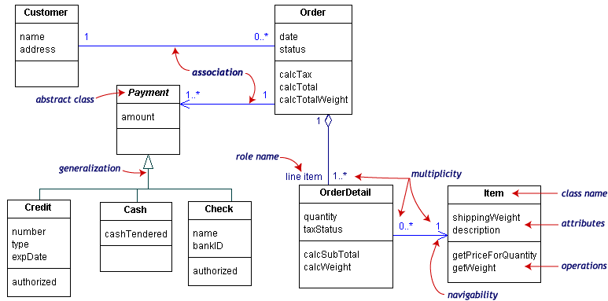
UML class notation is a rectangle divided into three parts: class name, attributes, and operations. Names of abstract classes, such as Payment, are in italics. Relationships between classes are the connecting links.

Our class diagram has three kinds of relationships.
- Association -- a relationship between instances of the two classes. There is an association between two classes if an instance of one class must know about the other in order to perform its work. In a diagram, an association is a link connecting two classes.
- Aggregation -- an association in which one class belongs to a collection. An aggregation has a diamond end pointing to the part containing the whole. In our diagram, Order has a collection of OrderDetails.
- Generalization -- an inheritance link indicating one class is a superclass of the other. A generalization has a triangle pointing to the superclass. Payment is a superclass of Cash, Check, and Credit.
An association has two ends. An end may have a role name to clarify the nature of the association. For example, an OrderDetail is a line item of each Order.
A navigability arrow on an association shows which direction the association can be traversed or queried. An OrderDetail can be queried about its Item, but not the other way around. The arrow also lets you know who "owns" the association's implementation; in this case, OrderDetail has an Item. Associations with no navigability arrows are bi-directional.
The multiplicity of an association end is the number of possible instances of the class associated with a single instance of the other end. Multiplicities are single numbers or ranges of numbers. In our example, there can be only one Customer for each Order, but a Customer can have any number of Orders.
This table gives the most common multiplicities.
Multiplicities | Meaning
0..1 | zero or one instance. The notation n . . m indicates n to m instances.
0..* or * | no limit on the number of instances (including none).
1 | exactly one instance
1..* | at least one instance
Every class diagram has classes, associations, and multiplicities. Navigability and roles are optional items placed in a diagram to provide clarity.

